O’Bannon Bank
Password Self Reset Instruction

These instructions will assist you in setting up your Online Banking Password Self Reset. After setting up your challenge question within Online Banking you can click on the “Forgot Password” link to reset your password anytime you have forgotten your Password.

You must have set up your Password Reset Question and Password Reset Answer in your online banking for this option to work.

Step 1 – Set Password Reset Question and Answer
- Enter your username and password on the Online Banking login page
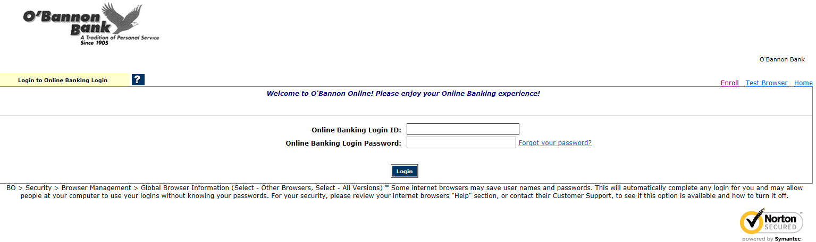

2. On the main page click on the Options tab
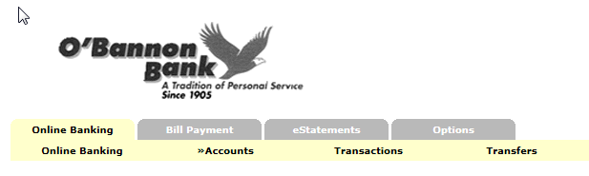

- Under Modify Personal Settings – Enter a Password Reset Question – Enter a
Password Reset Answer
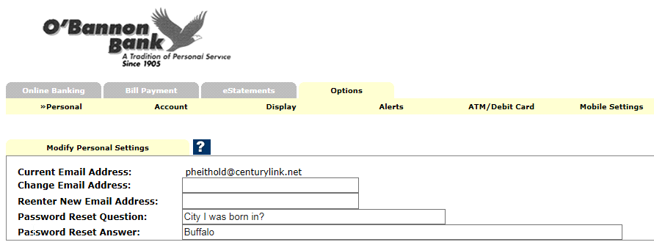
The reset question and answer should be something that you would easily remember but something that would not be easy for someone else to answer.

Example – Password Reset Questions: Name of your first stuffed animal?
Password Reset Answer: Bumper

- After you enter both the question and answer click “submit” at the bottom of the page.

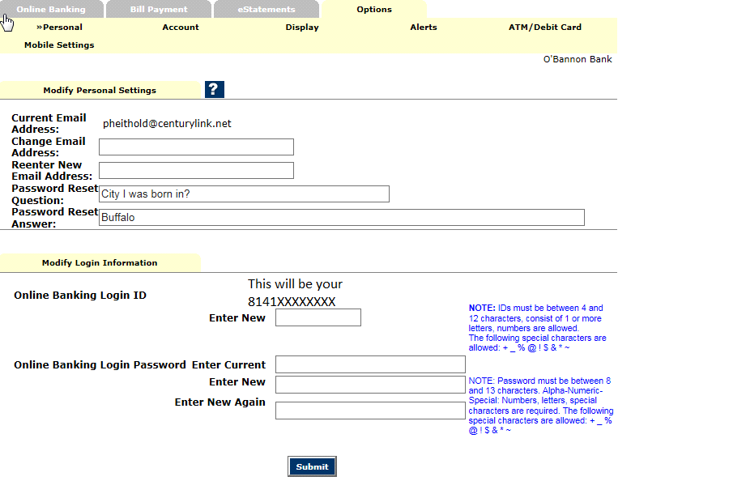

You have now successfully setup your Password Self Reset!

Step 2 – Requesting a Temporary Password

- From the Online Banking login page click on the Forgot Your Password? link
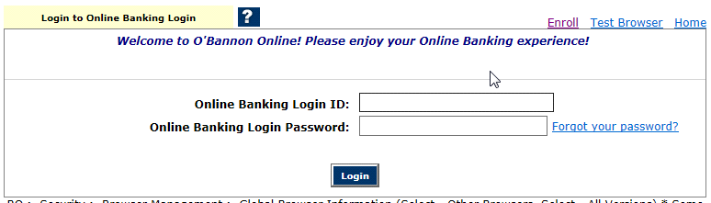

- Enter your login ID or pseudo name – Enter your email address – Enter an E-Mail Subject
The email subject is to identify the email sent to you to reset your Password – it can be anything you want to appear in the subject line of the email – for example . . . I need help – then click “Continue”

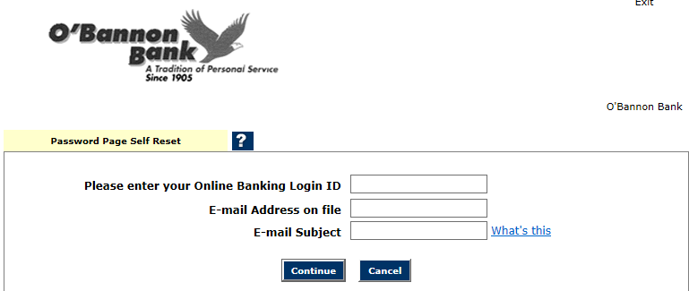

- The following message will come up after you click continue

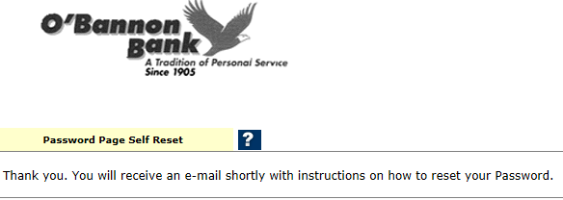

- Log into your email account to get the reset message

Note the subject line-reset for testing- open the email
The link in the email will be valid for two hours

- Click on the link in the email

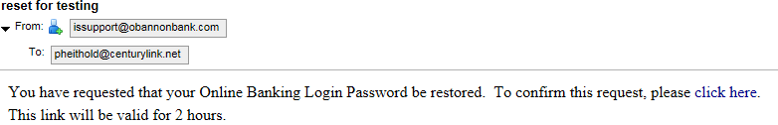

- Enter your Login ID or Pseudo name and answer the Reset Question and click “Continue”
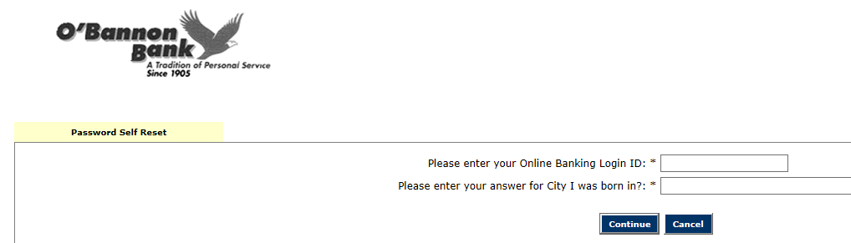

- You will be directed to a page that will ask you to enter a new Password and for you to verify the new Password and click “Continue”

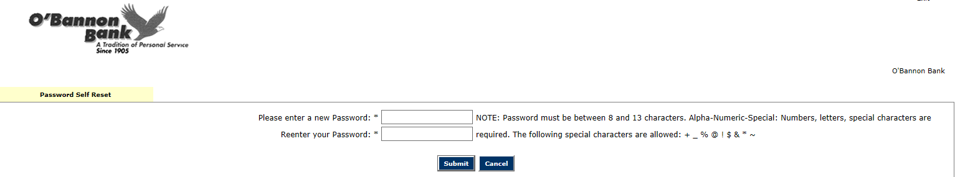

- After submitting the Password change you will receive a message saying that your Password has been successfully changed

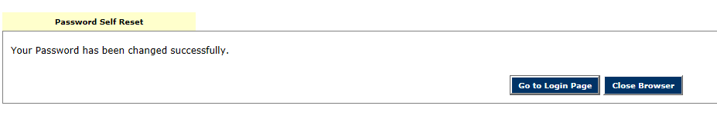

- You can now “GO to Login Page” and log into Online Banking with the Password you just set

